## Faculty of Computing

**Class: BSE-Section A 2025  
Course: Applications of ICT**

# **Lab 03: Programming concepts (Assembly and Python, Git_Github)**

**Date: 29, Sept 2025**

**Student Name:**

**1. Muhammad Ali**

**2. Sajeel Nadeem**

**LMS ID:**

**1. 553575**

**2. 540994**

**Part A: Assembly**

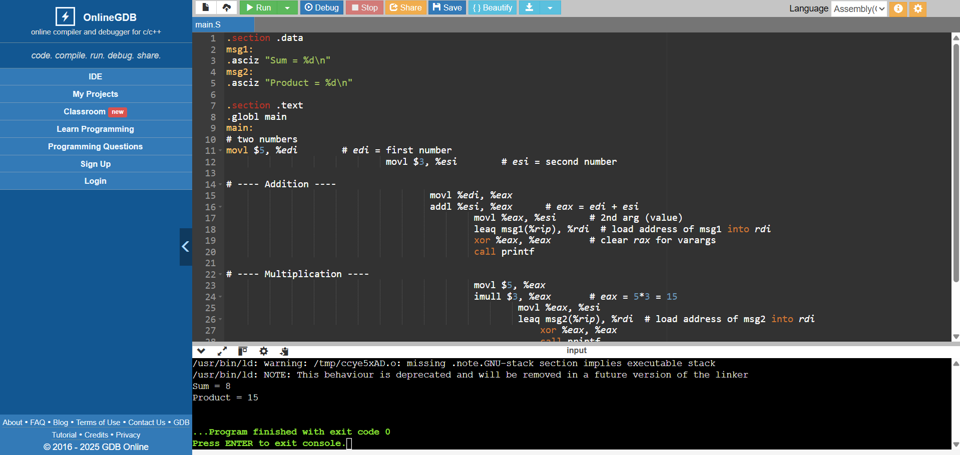

**Part B: Python**

